Clyfford Still Museum
Denver, CO

Project Details
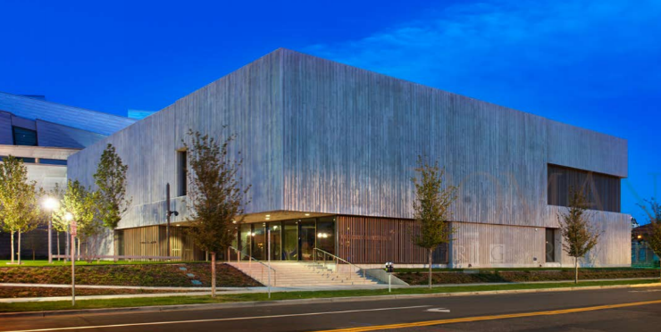
Description: 28,300 sf single-artist Museum
Owner: Clyfford Still Museum
Architect: Allied Works Architecture
CM/GC: Saunders Construction Inc.
Budget: $27,600,000
Completion: November 18, 2011

Project Description
The Clyfford Still Museum is a privately-funded, non-profit Colorado corporation formed to develop and manage the new single-artist museum adjacent to the Denver Art Museum in downtown Denver. The new museum houses the collected works of abstract expressionist Clyfford Still, approximately 2,600 works of art that were bequeathed to the City of Denver by his widow, Patricia Still, in 2004. Still’s artwork had been sealed off from both public and scholarly view while awaiting an American city to step forward to build exclusive and permanent quarters to house his collected works.
The state-of-the-art museum provides exhibition space, education, storage, conservation and research facilities with a high aspiration of architectural quality through use of materials, structure and lighting systems. The art is displayed in nine galleries on the second level that were thoughtfully arranged to allow for the chronological curation of the Clyfford Still collection. The galleries are day lit via an array of triple-paned, diffusing skylights, with a perforated cast-in-place concrete ceiling further filtering the strong Colorado sun. The works on canvas not circulating in the galleries are stored in two vaults on the first level, uniquely visible to the public through enormous sliding glass doors. The 18-24 inch thick white concrete structure serves to both insulate the building from the extremes of temperature and humidity outside, and to provide a canvas for the visibly raw surface texture that elegantly contrasts with the otherwise simple and unprovocative form of the building.

Scope of Services
While at Romani Group, Eric Shafran served as Project Director for the duration of the design and construction of the Museum, overseeing and managing virtually all aspects of the project over a five-year period. Responsibilities included:
- Ongoing development and management of the project budget, including monthly management, tracking and reporting to the client of all change orders, contingency usage, budget transfers and commitment levels.
- Close supervision of the project schedule, with control over critical design, preconstruction, construction, utility, FF&E and building systems commissioning milestones;
- Supervision of a highly complex land-swap process and multiple-alley vacation with City of Denver attorneys and the Museum’s outside counsel;
- Oversight of the architectural design team and close tracking of their progress towards both achieving the Museum’s programmatic and aesthetic/architectural goals, as well as construction cost targets;
- Design and selection of the Museum’s art storage systems (works on canvas, works on paper and archival materials), as well as the design of the Museum’s Conservation Lab in collaboration with subject-matter experts Sarah Melching and James Squires;
- Selection, negotiation and management of the Construction Manager/General Contractor through a preconstruction agreement and a three-phase Guaranteed Maximum Price construction contract;
- Monthly construction draw reviews and daily monitoring and negotiation of potential and realized construction change orders;
- Negotiation, engagement and management of contracts with 14 secondary consultants in the fields of environmental remediation, building commissioning, survey, network and security design, audio/visual and signage design, structured cabling, and LEED® certification;
- Furniture Fixtures and Equipment (FF&E) selection and procurement, including museum-specific and specialized art-storage systems, through 16 distinct vendors and specialty fabricators;
- Coordination of close-out activities with all vendors and consultants;

The Museum was completed on-schedule and under-budget.

